Chemistry 141 Name
Dr. Cary Willard
Exam 2A October 20, 2009

Multiple Choice (30 points)

Page 1 (18 points)

Page 2 (20 points)

Page 3 (13 points)

Page 4 (12 points)

Page 5 (16 points)

Total (109 points)

Chemistry Formulas

Kinetic energy = ½ mv²
w = -PΔV
P_{total} = P₁+P₂+P₃+…
u = (3RT/MW)^{½}
ΔG = ΔH - TΔS
PV = nRT
Rate ∝ (MW)^{-½}
P₁=X₁*P_{total}
C = q/ΔT
P_{total} = P₁ + P₂ + P₃ + …
M = mol/L
K = ºC + 273.16
w=dxF
E = mc²

HΨ=EΨ
M₁V₁ = M₂V₂
P_{total} = P₁ + P₂ + P₃ + …
M = mol/L
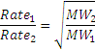
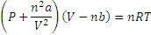
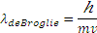
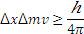

Constants

h = 6.626 x 10⁻³⁴ J sec
c= 2.9979 x 10⁸ m/sec
e = 1.602 x 10⁻¹⁹ C
N_{A} = 6.022 x 10²³/mol
k = 1.381 x 10⁻²³ J/K
K = ºC + 273.16
1 kcal = 4.184 kJ
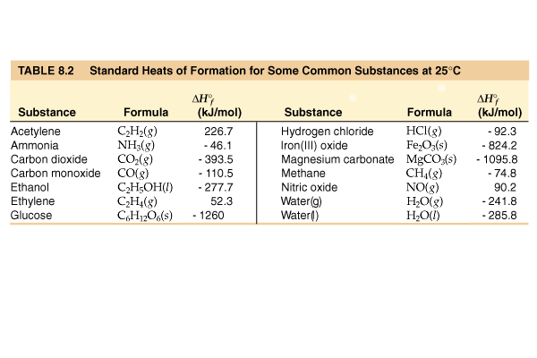
R = 0.0821 L atm/mol K = 62.4 L torr/mol K = 8.31 kJ/mol K
Standard Temperature and Pressure = 0ºC and 1 atm
760 torr = 760 mm Hg = 1.00 atm = 101 kPa = 14.6 psi = 30 in Hg
Specific heat water = 4.184 J/g K
Specific heat Al = 0.902 J/ g K
Specific heat Cu = 0.385 J/g K
ΔH_{vaporization} (H₂O) = 2260 J/g
ΔH_{fusion} (H₂O) = 333 J/g

mass electron = 9.109 x 10⁻³¹ kg

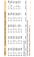
Average Bond dissociation Energies (kJ/mol)
H—H 436* | C—H 410 | N—H 390 | O—H 460 | F—F 159*
H—C 410 | C—C 350 | N—C 300 | O—C 350 | Cl—Cl 243*
H—F 570* | C—F 450 | N—F 270 | O—F 180 | Br—Br 193*
H—Cl 432* | C—Cl 330 | N—Cl 200 | O—Cl 200 | I—I 151*
H—Br 366* | C—Br 270 | N—Br 240 | O—Br 210 | S—F 310
H—I 298* | C—I 240 | N—I | O—I 220 | S—Cl 250
H—N 390 | C—N 300 | N—N 240 | O—N 200 | S—Br 210
H—O 460 | C—O 350 | N—O 200 | O—O 180 | S—S 225
H—S 340 | C—S 260 | N—S | O—S 364
C=C 611 | C=O 732 | O=O 498* | O=S 535 | N=O 598
C≡C 837 | C≡N 891 | N≡N 946*
*Bond dissociation energies for diatomic molecules are exact.
Part I -- Multiple choice questions (30 points)

- Suppose you needed to closely monitor small changes in pressure inside a container using an open end manometer. For the best accuracy, the substance in the manometer should

  - Be mercury
  - Be a gas
  - Have a low density
  - Have a high density

- According to the kinetic molecular theory, the pressure of a gas in a container will increase if the
  - number of collisions with the container wall decreases.
  - temperature of the gas increases.
  - number of moles of the gas decreases.
  - volume of the container increases.

- Which statement about real gases is true?
  - Forces of attraction and repulsion exist between gas particles at close range.
  - The mass of the gas particles is zero.
  - The behavior of real gases can be exactly predicted using the ideal gas law.
  - The volume of the gas particles is zero.

- You are given two flasks of equal volume. One contains H2 at 0ºC and 1 atm while the other contains CO2 at 0ºC and 2 atm. Which of the following quantities will be the same for both flasks?

  - average molecular speed
  - number of molecules present
  - density
  - average molecular kinetic energy

- Which one of the following gases will have the lowest rate of effusion?
- SF4 | - SO3 | - S2O5 | - SCl4

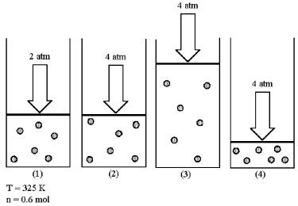
- Assume that you have a sample of gas in a cylinder with a moveable piston, as shown in diagram (1). The initial pressure, number of moles, and temperature of the gas are noted on the diagram.

Which diagram (2)-(4) most closely represents the result of doubling the pressure while keeping the temperature and number of moles of gas constant?
  - Diagram 2
  - Diagram 3
  - Diagram 4
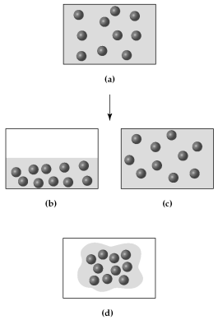
- Assume that you have a sample of gas at 300 K in a sealed container, as represented in (a).

Which of the drawings (b)-(d) represents the gas after the temperature is lowered from 300 K to 200 K?
  - Drawing b
  - Drawing c
  - Drawing d
- Three identical flasks contain three different gases at standard temperature and pressure. Flask A contains C₄H₁₀, flask B contains SO₂, and flask C contains He. Which flask contains the largest number of molecules?
  - flask A
  - flask B
  - flask C
  - All contain same number of molecules.

- The nutritional calorie (abbreviated Cal) is equal to

  - 4.184 J
  - 4.184 cal
  - 1 kcal
  - 1000 kcal

- For most chemical reactions
  - ΔE is much larger than ΔH.
  - ΔH is equal to ΔE.
  - ΔH is much larger than ΔE.
  - the difference between ΔH and ΔE is very small.

- For a particular process that is carried out at constant pressure, 125 kJ of heat is released and 15 kJ of work is done. Therefore,

  - ΔE = −140 kJ and ΔH = −125 kJ.
  - ΔE = −110 kJ and ΔH = −125 kJ.
  - ΔE = −125 kJ and ΔH = 140 kJ.
  - ΔE = −125 kJ and ΔH = −110 kJ.

- Water has an unusually high
- Calorimeter constant | - heat of formation
- heat of combustion | - specific heat

- For which should the standard heat of formation ΔHºf, be zero at 25ºC?

  - O (g)
  - O₂ (g)
  - O₃ (g)
  - All of the above

- The values of ΔHºf for the three states of benzene are approximately -22 kcal/mol, -11 kcal/mol, and 20 kcal/mol. Which is the value for solid benzene?
  - -22 kcal/mol
  - 20 kcal/mol
  - -11 kcal/mol
  - cannot be determined without additional information

- Which equation represents the reaction whose ΔH, represents the standard enthalpy of formation of CHCl3(l) at 25ºC? (i.e., for which is ΔH = ΔHºf of CHCl3)
  - CHCl3(l) → C(s) + H(g) + 3 Cl(g)
  - C(s) + H(g) + 3 Cl(g) → CHCl3(l)
  - C(s) + 1/2 H2(g) + 3/2 Cl2(g) → CHCl3(l)
  - 2 C(s) + H2(g) + 3 Cl2(g) → 2 CHCl3(l)

Part II -- Problems (79 points)

- (4 points) Carry out the following conversions
  - 352 torr to kPa

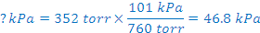

  - 0.255 atm to mm Hg

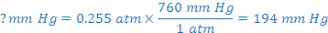

- (9 points) A compressed air tank carried by scuba divers has a volume of 8.0 L and a pressure of 140 atm at 20ºC.
  - What would the pressure of the air be in a tank with a volume of 14.0 L?

  - What would the pressure of the air in the tank be if the temperature increased to 45ºC?

  - What is the volume of air in the tank in liters at STP (0ºC and 1 atm)?

- (5 points) Methane gas, CH₄, is sold in a 43.8 L cylinder containing 5.54 kg. What is the pressure inside the cylinder in atm if the temperature is 21ºC?

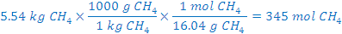

- (5 points) Use kinetic molecular theory to explain the change in pressure that results from warming a sample of gas.

As the gas warms, the speed of the molecules increases thus hitting the surfaces harder and increasing pressure.

- (5 points) What is the pressure in millimeter of mercury inside a container of gas connected to a mercury-filled open-end manometer when the level in the arm connected to the container is 17.6 cm lower than the level in the arm open to the atmosphere and the atmospheric pressure reading outside the apparatus is 754.3 mm Hg?
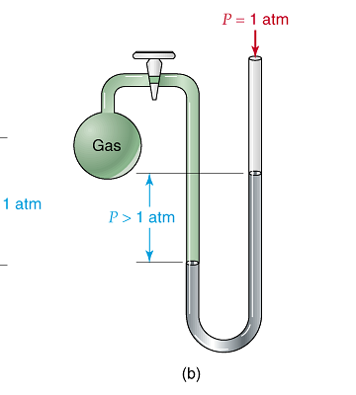
Pressure gas =pressure atmosphere + pressure Hg

Pressure gas = 176 mm Hg + 754.3 mm Hg

Pressure gas = 930 mm Hg

- (5 points) An unknown gas is placed in a 1.500 L bulb at a pressure of 356 mm Hg and a temperature of 22.5 ºC, and is found to weigh 0.9847 g. What is the molecular mass of the gas?

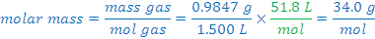

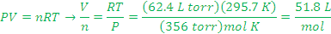

- (5 points) If a 0.500 mole sample of Krypton requires 16.7 minutes to effuse through a porous membrane and a 0.500 mole sample of an unknown gas requires 35.4 minutes, calculate the molar mass of the unknown gas.

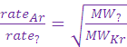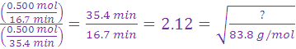

- (4 points) Sodium metal is sometimes used as a cooling agent in heat exchange units because of its relatively high molar heat capacity of 28.2 J/mol ºC. What is the specific heat of sodium in J/g K?

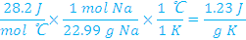

- (9 points) The bombardier beetle uses an explosive discharge as a defense mechanism. The chemistry of the reaction involved is the oxidation of hydroquinone by H₂O₂ to produce quinone and water.
C₆H₄(OH)_{2(aq)} + H₂O_{2(aq)} → C₆H₄O_{2(aq)} + 2 H₂O_{(l)}

Given the following reactions, calculate ΔH.

C₆H₄(OH)_{2(aq)} → C₆H₄O_{2(aq)} + H_{2(g)} ΔH = + 177.4 kJ
H_{2(g)} + ¹/₂O_{2(g)} → H₂O_{(g)} ΔH = − 241.8 kJ
H_{2(g)} + O_{2(g)} → H₂O_{2(aq)} ΔH = −191.2 kJ
H₂O_{(g)} → H₂O_{(l )} ΔH = − 43.8 kJ

C₆H₄(OH)_{2(aq)} → C₆H₄O_{2(aq)} + H_{2(g)} + 177.4 kJ
H₂O_{2(aq)} → H_{2(g)} + O_{2(g)} +191.2 kJ
2(H_{2(g)} + ¹/₂O_{2(g)} → H₂O_{(g)} ) 2(−241.8 kJ) = − 483.6 kJ
2(H₂O_{(g)} → H₂O_{(l )}) 2(−43.8 kJ) =−87.6 kJ

C₆H₄(OH)_{2(aq)} + H₂O_{2(aq)} → C₆H₄O_{2(aq)} + 2 H₂O_{(l)} − 202.6 kJ

How much heat is produced by a bombardier beetle that produces 15.0 mg of quinine?

- (6 points) The standard enthalpy of combustion of cyclohexane (C₈H₁₆) is −1186.0 kJ/mol. The products of this combustion are liquid water and carbon dioxide gas. Calculate the standard enthalpy of formation of liquid n-heptane
C₈H₁₆(g) + 12 O₂(g) ⎯→ 8 CO₂(g) + 8 H₂O(l)

ΔHc, (C₈H₁₆, g) = 8(ΔH_{f}, CO₂, g) + 8 (ΔH_{f}, H₂O, l)- 1 (ΔH_{f}, C₈H₁₆) – 12(ΔH_{f}, O₂, g)

-86  kJ = 8(-393.5 kJ) + 8 (-285.8 kJ) - 1 (ΔH_{f}, C₈H₁₆) – 12(0 kJ)

-1186.0 kJ = -3148.0 kJ + -2286.4 kJ - (ΔH_{f}, C₈H₁₆) -0 kJ

-1186.0 kJ = -5434.4 kJ - (ΔH_{f}, C₈H₁₆)

- (ΔH_{f}, C₈H₁₆) = + 4248.4 kJ

(ΔH_{f}, C₈H₁₆)= -4248.4 kJ/mol

- (6 points) Determine the energy of the following reaction using bond dissociation energies.

Bonds broken |  |  | Bonds formed
8 S-S bonds | 8 (+ 225 kJ) |  | 8 S-O bonds | 8(--364 kJ)
8 O=O bonds | 8 (+ 498 kJ) |  | 8 S=O bonds | 8(--535 kJ)
total | +5784 kJ |  |  | --7192 kJ

DH reaction = +5784 kJ + (--7192 kJ) = --1408 kJ

- (16 points) A sample of an unknown metal was reacted with 150.0 g of hydrochloric acid in a calorimeter.
  - If a 3.457 g sample of the metal caused the temperature of the calorimeter and its contents to rise from 22.4ºC to 72.1ºC, calculate the heat of reaction per g for the metal. (The acid solution has a specific heat of 4.168 J/g K, and the calorimeter has a heat capacity of 39.2J/K.)

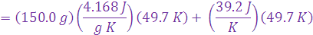

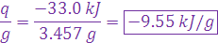

  - The hydrogen gas from the experiment above was collected in a 785 mL container at 30.0ºC and 731 torr pressure, how many moles of hydrogen were collected?

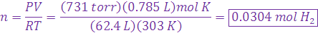

  - What is the molar mass of the metal? (Previous experiments have shown the metal to form a chloride of the formula MCl₃. Write a balanced chemical reaction and determine how many moles of the metal reacted.)

M + 3 HCl → MCl₃ + ³/₂ H₂
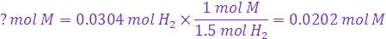

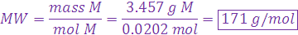

  - Calculate the molar heat of reaction of the metal.
